Lecture 7
What are GRASP patterns?:
GRASP stands for general responsibility assignment software principles, it consists of 9 design patterns to help identify which object handles which tasks, it’s has the fundemantals of software architecture patterns. Its like learning the alphabets when it comes to software architecture and patterns. It helps achieve high cohesion and low coupling. For robust maintainable system.
What does KISS stand for?:
It stands for Keep it simple and short. It means when designing a system we should only include the classes and features that we need no over engineering and no complex classes that would only increase the complexity of the system understanding. Also we need to make sure that its not simpler, meaning too simple that it does not deliver the implicit and explicit requirements.
What does a pattern mean and its origin:
Patterns are reusable solutions to recurring problems, originally from building architecture, where the same core idea can be applied in infinitely many unique ways to solve similar problems — and software design borrowed this powerful concept.
Some example patterns: two sides, window seat, deep balacony.

Two Sides pattern: when applying a design pattern we have to make some trade-offs,
Some benefits of a design patterns are, makes the design maintainable, the software engineer can get the system right faster, the communication between the teams becomes easier.
Some withdraws are, we need then more classes, the architecture becomes bigger; meaning we have more classes, we need more physical resources. The system becomes slower. And bigger.
However, in modern tech. the real issue that the corporations are facing is the architecture complexity not the resources cost.

Essential Elements of a Pattern: to have a design pattern we should have some criteria for it to be called a pattern
A Name: to maintain a common way of describing and understanding the pattern, increases the vocab.
A problem: the case where this design pattern should be used, and sometimes a checklist for the conditions under which the pattern should be applied.
Solution: The solution describes the elements needed for the pattern, their relationships, responsibilities, and interactions. However, it is only an abstract design — not a concrete code implementation. The exact code will vary depending on the programming language and context.
Consequences: the withdraws of implementing this pattern, consequences are critical to evaluate the implementation before implementing it.

Gang of Four GoF:
Most classic design patterns we hear about were defined in the GoF book. It organized patterns in a catalogue-like style and gave a template for pattern description and recognition.
The book had a template for software design patterns and had a template that can be filled to describe each pattern in the same way; the template to be filled is:
Pattern Name and Classification, Intent, Also Known As, Motivation, Applicability, Structure, Participants, Collaborations, Consequences, Implementation, Sample Code, Known Uses, Related Patterns.

GoF patterns can be classified (categorized) into 2 different independent categories. One is based on its purpose and the other category Is based on its scope (class level or object level)
Scope: class level meaning it can be done in compile time using inheritance, and object level which means it can be applied in run time
Purpose: the purpose of a pattern answers one of those 3 questions, how can we create an object (creational) like a factory method for example a java spring boot bean creation, so we don’t need to create it everywhere the factory creates a bean ones for us and we use it,
how can we structure an object and compose them together, adapter
how can i make 2 objects communicate, For example, the Observer pattern allows one object to notify multiple others when something happens, like a button click triggering several event listeners.

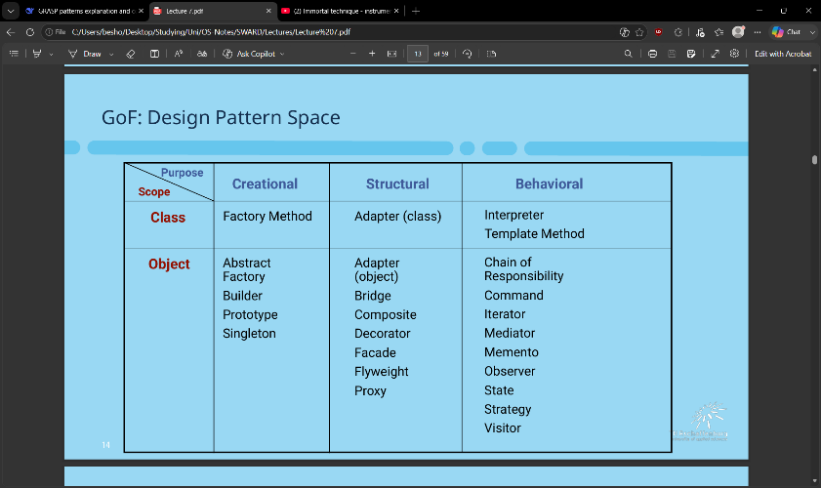

Selected Gang of Four (GoF) Design Patterns:
Adapter Pattern (GoF):
The problem is that we have 2 objects that need to communicate to calculate something or solve an issue, however the requesting method expects or uses a different method from the provider. To solve this problem, we create an adapter class of type interface. This interface has a unified method that works for all classes. We then make the requesting class communicate with it. So for the example called calculate taxes. so the methods are incompatibale, for this we create an interface called taxadapter that has a method called taxCalc(), and each time we need the taxes we make the sale object use that interface with the system so one is for TaxMasterSystem, and one for any other system using a unified method.

create an interface that unifies the operation, then we make each class we need to do the calculation implement it in a new adapter. we then use the interface inside the requester to make it call the provider
for that example we create an interface called TaxCalc and make each tax providing service implement it in a new class. So taxMasterAdapter implement TaxCalc and wrap the calculating function of taxmastersystem inside the taxmaster adapter. We then pass to the sale the taxCalc to the Sale and make it call the taxmasteradapter
// Step 1: Create interface that unifies the operation
interface TaxService {
double getTaxes(Sale sale);
}

// Step 2: Make each class implement it in a new adapter
class TaxMasterAdapter implements TaxService {
private TaxMasterSystem system = new TaxMasterSystem();

public double getTaxes(Sale sale) {
return system.calculateTaxes(sale.getTotal());
}
}

class AnotherTaxAdapter implements TaxService {
private AnotherTaxSystem system = new AnotherTaxSystem();

public double getTaxes(Sale sale) {
return system.getTaxAmount(sale);
}
}

// Step 3: Use the interface inside the requester to call the provider
class Sale {
private TaxService taxService;

public Sale(TaxService taxService) {
this.taxService = taxService; // Inject the adapter
}

public double getTotalWithTax() {
// Requester uses the interface to call the provider
double taxes = taxService.getTaxes(this);
return getSubtotal() + taxes;
}
}

The adapter acts as an indirection
The Adapter design pattern is a kind of Indirection and a Pure Fabrication, that uses Polymorphism.

Factory pattern:
Problem: who should be responsible for creating objects at run time when we have no idea what type of object we need to deal with.
Solution: create a fabrication class called factory to create the objects for us during the runtime
note that the factory methods return objects typed to an interface rather than a class, so that the factory can return any implementation of the interface
aka simple or concrete factory

Singleton pattern:
Problem: we need one instance object of a certain class and we need everyone in the application to access it.
Solution: Create a static method on the class level that creates and controls the access to exactly one and only one instance of that class.
This singleton pattern can be applied to fabrication factory classes, for example ServicesFactory, and in the sequence diagram a singleton class will be annotated with 1 indicating only one instance of that class.
Explaining the class diagram of the singleton:
At the top we see the class name and the number 1 meaning it’s a singleton
Then we have the variable names and their return types, in the class diagram if a variable is underlined that means it’s a static variable or a method.
In a singleton we always have a variable that is static called instance and of type of the same class.
We also always have a static underlined method called getInstance() to get an object of that type.
An example implementation:
public static synchronized ServicesFactory getInstance()
{
if ( instance == null )
instance = new ServicesFactory()
return instance }

Explaining sequence diagram of page 26: the Register uses an adapter to check for which accounting service to use without a problem, then a ServiceFactory which is a singleton, also acts like a factory that creates the wanted service, am i correct? this way we capture 3 design patterns, singleton, factory, adapter

Strategy Pattern (GoF):
Motivation: we need different implementation based on the business logic, that changes frequently for the same purpose, calculating discount, calculating taxes, or so on. we need a way to separate the algorithms that calculates this logic into different classes that can be decided in runtime environment
Problem: how to design a good design for related but different algorithms, how to create a design that is open for extension and closed for change.
Solution: define each algorithm in its own class, and make them all operate under the same interface which will be used by the requesting class to call the method.
The strategy object is used by a context object, the context object in this case the sale object delegates to the strategy object to do its work for it. For this example the sale uses sale.gettotal() and the gettotal delegates to the get total inside the interface of the type strategy
GRASP patterns applied in strategy: indirection, pure fabrication, polymorphism

Composition Pattern:
Motivation: sometimes we need to apply multiple algorithms from multiple conditions of our strategy classes. What if we have multiple discount factors that applies to the same Sale.
Problem: how to treat a group of strategy classes as the same class, group strategy classes in other words.
Solution: we create a composition class that implements the same interface, as the single algorithms and make it include multiple algorithms
is it the standard that the composite has children classes
A composite can hold many children (multiple strategies) and uses all of them at runtime.
its the normal to have a composite that has children strategies and that composite has other strategies at the same level
We create an abstract parent composite that defines an empty list variable. Each child composite then adds its own chosen strategies to its own copy of the list.
GRASP strategies applied: Polymorphism, open/closed principle, protected variation

Observer Pattern:
Problem: the publisher object needs to notify all the concerned objects that needs to know this update without knowing who are these objects.
Solution: the subscribers implement the interface called subscriber, and the event updater object calls update method on that interface just one time and all objects with subscriber implementation gets the update

MVC Pattern: Model Controller View
Model: it collaborates with, the controller and the view classes/
handles the CRUD through an API for example JPA interface, and has the business logic in service classes. And notifies dependent components when a change happens in the data.
Controller: collaborates with, the model and the view
It takes the input from the user, translates the user input into data that the model and the view can understand, it takes a reaction based on the model if needed.
View: it collaborates with the controller, and the model.
Retrieves data from the model and show it to the user. It shows updated model data through refreshesThe View creates the Controller that will handle its user input events

In our POS system we have an example of the total sale amount, we don’t input anything so the controller is not involved. But we have the amount and everytime the model updates and this amount changes the model updates and the view refreshes and show the new data.
Example Observer Pattern:
The Sale class (the publisher) has a method that’s called
publishPropertyEvent( name, value ) this is the notification itself
and another method addPropertyListener( PropertyListener lis ) this adds a subscriber
the PropertyListener is an interface and any class that implements it can get access to this notification this way the Sale class does not have to store every class
SaleFrame1 is an example class that implements the PropertyListener Interface
Sale the publisher class stores the classes that implements the PropertyListener Interface in a list.
{ for each PropertyListener pl in propertyListeners pl.onPropertyEvent( this, name, value ); } this method here takes each class in the list and notifies it.
The SaleFrame1 Class can initialize an event based on this notification

Anti-Patterns:
Anti-patterns are design solutions that are destructive but maybe look or sound helpful at the first glance.
Anti-patterns spot the problems with the design and help us fix it or avoid it.
Managerial: Bad habits in how you manage the team and project
Archtiectural: bad patterns that you do while designing the architecture diagrams, and the entire system structure
Dev: bad patterns when writing codes
Example;
Anti-Pattern Name: Analysis Paralysis (215)
Also Known As: Waterfall, Process Mismatch
Most Frequent Scale: System
Refactored Solution Name: Iterative-Incremental Development
Root-Causes: Pride, Narrow-Mindedness
Unbalanced Forces: Management of Complexity
Anecdotal Evidences:
“We need to redo this analysis to make it more object-oriented.” “We need to complete the design before we can start coding.”

Solution for anti-patterns is iterative development and consistent reviews

